ModbusPM

Protocol Macro
MODBUS for
CS1/CJ1 series
MAN STA42

Operation Manual

OMRON

Table of contents

1. Specifications 3
2. ModbusPM Master interface 4
2.1. Principe 4
2.2. Ladder program 5
2.3. Read 1 bit (function 01 or 02) 6
2.4. Read n words (function 03 or 04) 6
2.5. Write 1 bit (function 05) 7
2.6. Write 1 bit to N slaves 7
2.7. Write 1 word (function 06) 8
2.8. Write 1 word to N slaves 8
2.9. Write n words to 1 slave (function 10) 9
2.10. Write n words to N slaves 9
3. ModbusPM slave interface 10
3.1. Principe 10
3.2. Operation 11
3.3. PMSU configuration. 11
4. Downloading the protocol macro 12
4.1. program adaptations 12
4.2. Flags and control bits of PMSU 14

Specifications
ModbusPM is a protocol macro developed for CJ1/CS1 series providing master and slave Modbus interfaces.
The following functions codes are implemented :
01 : Read n bit (output)
02 : Read n bit (input)
03 : Read n words (register)
04 : Read n words (input)
05 : Write 1 bit
06 : Write 1 word
10 : Write n words

Write command (05-06-10) can be sent to N consecutive slave
The Slave interface needs a ladder program (ModbusPM.cxp) to prepare data according to the read/write master request. The Read/Write command are executed in the DM area
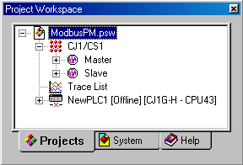

ModbusPM Master interface

Principe
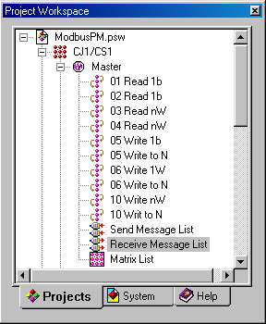MobusPM Master interface provide 10 sequences of read/write command.
Write to N commands can be sent to several slaves which should be consecutive.

Command should be specified through operand C2 of PMCR instruction.

sequence | Designation | Operation
000 | 01 Read 1b | Read 1 bit
001 | 02 Read 1b | Read 1 bit
002 | 03 Read nW | Read n words
003 | 04 Read nW | Read n words
004 | 05 Write 1b | Write 1 bit
005 | 05 Write to N | Write 1bit to N slaves
006 | 06 Write 1W | Write 1 word
007 | 06 Write to N | Write 1 word to N slaves
008 | 10 Write nW | Write n words
009 | 10 Writ to N | Write n words to N slaves
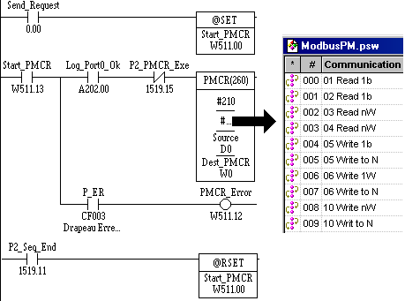

Ladder program

In case of no response or wrong response, the sequence is cancelled and Sequence End Flag does not change.
If you change the sequence number, be sure to use hexadecimal format in PMCR instruction.

Read 1 bit (function 01 or 02)

 |  |  | @PMCR(260)
 |  |  | C1
 |  |  | #0 or #1 |  |  | Request
response |  |  | Source | → | S | 3 words
n+1 | D | ← | Destination |  | S+1 | Slave number
data | D+1 |  |  |  | S+2 | Address

Example :Read bit 0 from slave n°1 address 00AD.
Logical port n°0, Port RS232C n°2, Unit CJ1W-SCU41 n° 0 (SCU +10)
Request : 01 01 00AD 0001 6C2B
Response :01 01 01 01 9048
Dest | Resp |  | Source | Request
W0 | 0002 | 2 words | D | 0003 | 3 words
W1 | 0001 | data | D1 | 0001 | slave n°1
 |  |  | D2 | 00AD | address

Read n words (function 03 or 04)

 |  |  | @PMCR(260)
 |  |  | C1
 |  |  | #2 or #3 |  |  | Request
response |  |  | Source | → | S | 4 words
n+1 | D | ← | Destination |  | S+1 | Slave number
Data 1 | D+1 |  |  |  | S+2 | Address
Data n | D+n |  |  |  | S+3 | Number of word

Example :Read 2 words from slave n°1 address 00AD.
Logical port n°0, Port RS232C n°2, Unit CJ1W-SCU41 n° 0 (SCU +10)
Request : 01 03 00AD 0002 55EA
Response :01 03 0004 1111 2222 8E87
Dest | Resp |  | Source | Request
W0 | 0003 | 3 words | D | 0004 | 4 words
W1 | 1111 | Data 1 | D1 | 0001 | slave n°1
W2 | 2222 | Data 2 | D2 | 00AD | address
W3 | ---- |  | D3 | 0002 | 2 words

Write 1 bit (function 05)

@PMCR(260)
C1
#4 |  |  | Request
Source | → | S | 4 words
Destination |  | S+1 | Slave number
 |  | S+2 | Address
 |  | S+3 | 0000 or FF00

Example: Write to ON bit 00AD.00 of slave n°1.
Logical port n°0, Port RS232C n°2, Unit CJ1W-SCU41 n° 0 (SCU +10)
Request : 01 05 00AD FF00 1DDB
Response : 01 05 00AD FF00 1DDB (Response similar to the request)
Source
D0 | 0004 | 4 words
D1 | 0001 | slave n°1
D2 | 00AD | Address
D3 | FF00 | Write data
Write data : FF00= ON 0000= OFF

Write 1 bit to N slaves

@PMCR(260)
C1
#5 |  |  | Request
Source | → | S | 4 words
Destination |  | S+1 | Slave count
 |  | S+2 | Address
 |  | S+3 | 0000 or FF00

Example: write to ON bit 00AD.00 of slaves n°1,2 and 3.
Logical port n°0, Port RS232C n°2, Unit CJ1W-SCU41 n° 0 (SCU +10)
Request : 01 05 00AD FF00 1DDB then 02 05 00AD FF00 1DE8 then 03….
Response : 01 05 00AD FF00 1DDB (Response similar to the request)

Source
D0 | 0004 | 4 words
D1 | 0003 | 3 slaves
D2 | 00AD | Address
D3 | FF00 | Write data

Each response will be written to Destination area. If one of the slaves does not respond, sequence will be aborted. Repeat counter value will designate the slave in error.

Write 1 word (function 06)

@PMCR(260)
C1
#6 |  |  | Request
Source | → | S | 4 words
Destination |  | S+1 | Slave number
 |  | S+2 | Address
 |  | S+3 | Write data

Example: Write 1111 in to slave n°1 at address 00AD.
Logical port n°0, Port RS232C n°2, Unit CJ1W-SCU41 n° 0 (SCU +10)
Request : 01 06 00AD 1111 D477
Response : 01 06 00AD 1111 D477 (Response similar to the request)

Source
D0 | 0004 | 4 words
D1 | 0001 | slave n°1
D2 | 00AD | Address
D3 | 1111 | Write data

Write 1 word to N slaves

@PMCR(260)
C1
# 7
Source | → | S | 4 words
Destination |  | S+1 | Slave count
 |  | S+2 | Address
 |  | S+3 | Write data

Example :Write 1111 in to slaves n°1, 2 and 3 at address 00AD.
Logical port n°0, Port RS232C n°2, Unit CJ1W-SCU41 n° 0 (SCU +10)
Request : 01 06 00AD 1111 D477
Response :01 06 00AD 1111 D477 (Response similar to the request)

Source
D0 | 0004 | 4 words
D1 | 0003 | 3 slaves
D2 | 00AD | Address
D3 | 1111 | Write data

Each response will be written to Destination area. If one of the slaves does not respond, sequence will be aborted. Repeat counter value will designate the slave in error.

Write n words to 1 slave (function 10)

 | @PMCR(260)
 | C1 |  | S | 5 words
 | # 8 |  | S+1 | Slave number
 | Source | → | S+2 | Address
 | Destination |  | S+3 | Number of words to read
 |  |  | S+4 | Bytes count (S+3)x2
 |  |  | S+5 | data 1
 |  |  | S+6 | data 2
 |  |  | S+n | data n
Example : Write 1111 and 2222 in to slave n°1 at address 00AD.
Logical port n°0, Port RS232C n°2, Unit CJ1W-SCU41 n° 0 (SCU +10)
Request : 01 10 00AD 0002 04 1111 2222 F5CE
Response :01 10 00AD 0002 D029

Source
D0 | 0007 | 7 words
D1 | 0001 | slave n°1
D2 | 00AD | Address
D3 | 0002 | Number of words to write
D4 | 0004 | Bytes count
D5 | 1111 | Data 1
D6 | 2222 | Data 2

Write n words to N slaves

@PMCR(260)
C1 |  | S | 5 words
# 9 |  | S+1 | slave count
Source | → | S+2 | Address
Destination |  | S+3 | Number of words to write
 |  | S+4 | Bytes count (S+3)x2
 |  | S+5 | Data 1
 |  | S+6 | Data 2
 |  | S+n | Data n
Example : write 1111 et 2222 in to slaves n°1,2 and 3 at address 00AD.
Logical port n°0, Port RS232C n°2, Unit CJ1W-SCU41 n° 0 (SCU +10)
Request : 01 10 00AD 0002 04 1111 2222 F5CE
Response :01 10 00AD 0002 D029

Source
D0 | 0007 | 7 words
D1 | 0003 | 3 slaves
D2 | 00AD | Address
D3 | 0002 | Number of words
D4 | 0004 | Bytes count
D5 | 1111 | Data 1
D6 | 2222 | Data 2

ModbusPM slave interface

Principe

ModbusPM slave provide 2 sequences :
- Read & Write
Functions 03-04-06-10h are implemented with the following restriction :
The write n word commands (10h) checksum is not checked.
- Write with CRC
This sequence allow only one function: write n word command (10h) but CRC is controlled.

The reason of such division is that sequence Read & Write use a matrix to compare the requests to identify the function then execute the appropriate step. Matrix case works only in these cases :
- similar Header and terminator.
2- header and size information in the request.
3- header and same size.

Modbus protocol does not use terminator, and most function do not use bytes count information. The above case 3 could be used but the size of the request such Write n word (Function code 10h) are bigger than others Functions. This is why function 10h is treated in two steps. The frame is truncated by the matrix first and the rest of the frame is read by another step which cannot use CRC control because one part of the frame is missing.
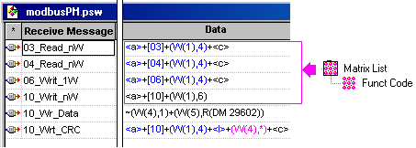

As soon as the PMSU receive 8 bytes, the request is compared in the matrix.
If the Function code is 03, 04 or 06 the request is executed by the CPU then answer is sent.
If the function code is 10, the rest of the request is still in the buffer of the PMSU.
Step 10_Wr_Data is executed to read the rest of the request.
This part contains address, number of words, bytes count but also the 1st byte of the 1st data to be written. The ladder program recovers this bytes and place it into the MSB of word W4. The rest of the frame is written starting from LSB of W4 ( "~" before (W(4),1) ).
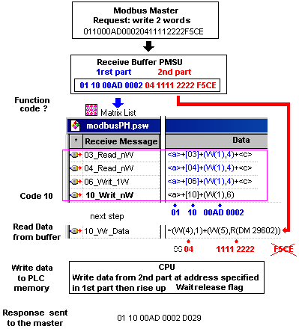

Operation
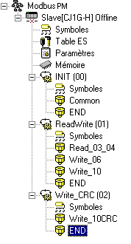Unlike the master interface, Slave interface should be assisted by a ladder program to prepare data from/to the address specified by the request.
If you only need to use function 10h with a CRC control, you must activate Task01 and de-activate task02.
Read/Write is executed into the DM area starting from 00000 to DM 32767 (7FFF) with a maximum of 96 words (60h) by command.
Common task store the slave number to HR1 which is used by C3 of PMCR. The other tasks transfer the data to the address specified by the master request. When data are ready, the “Wait Release” flag is activated by the task to allow the PMSU to continue the execution of the sequence. Only one task should be activated. Use the property windows to de-activate the task (01 or 02) according to the sequence used Read & Write or Write with CRC

Procedure :
- Adapt the ladder program ModbusPM.cxp to the PMSU used (see Ch. flags and control bits).
- Activate the Task 01 or 02.
- Specify the slave number in the common task.

PMSU configuration.

 | Serial Communications Boards |  | Serial Communications Unit
Reference | CS1W-SCB21 | CS1W-SCB41 | CS1W-SCU21 | CJ1W-SCU41
Port 1 | RS232C | RS232C | RS232C | RS-422A/485
Port 2 | RS232C | RS-422A/485 | RS232C | RS232C
API compatibles | CS1H-CPU67/CPU66/CPU65/CPU64/CPU63  CS1G-CPUCPU45/CPU44/CPU43/CPU42 |  |  | CJ1G-CPU45  CPU44

Communication port and Unit number (for SCU unit) determine the content of C1 of PMCR instruction.

Downloading the protocol macro

program adaptations

1- Specify the PLC type
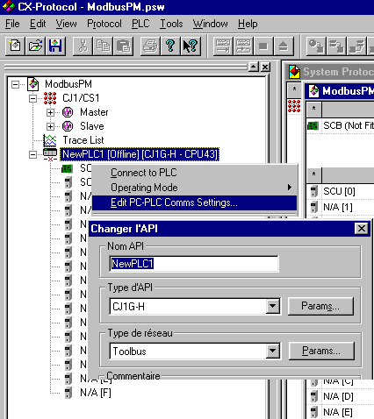
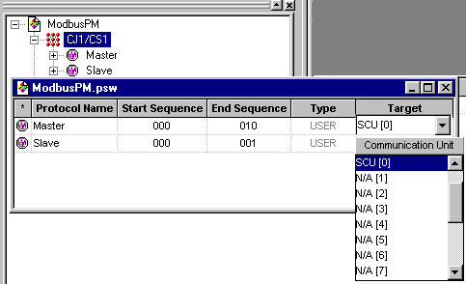2 specify the PMSU type

3 – Edit the communication Port settings (1 or 2) and select Protocol Macro and choose the correct format. (8 bits should be use for Modbus)
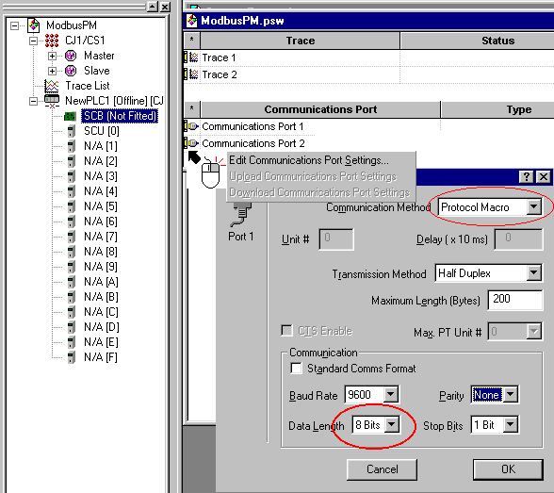
4- Connect then transfer the setup and the protocol (mastes or slave) into the PMSU.

Flags and control bits of PMSU
The address of flags and bits used by the ladder program are depending of the PMSU used.
Each unit use 25 words in CIO memory.
For SCB unit, n = 1900
For SCU unit, n = CIO 1500 + ( 25 x Unit number )
Port n°1
Symbol | Channel | Bit | SCB | SCU n°0 | SCU n°1
P1_Wait_Release | n | 00 | 1900.00 | 1500.00 | 1525.00
P1_Abort_Switch | n | 03 | 1900.03 | 1500.03 | 1525.03
P1_Seq_End | n + 9 | 11 | 1909.11 | 1509.11 | 1534.11
P1_PMCR_Exe | n + 9 | 15 | 1909.15 | 1509.15 | 1534.15
P1_Case_0 | n + 12 | 15 | 1912.00 | 1512.00 | 1537.00
P1_Case_1 | n + 12 | 01 | 1912.01 | 1512.01 | 1537.01
P1_Case_2 | n + 12 | 02 | 1912.02 | 1512.02 | 1537.02
P1_Case_3 | n + 12 | 03 | 1912.03 | 1512.03 | 1537.03
P1_Step_8 | n + 13 | 08 | 1913.08 | 1513.08 | 1537.08
P1_Step_9 | n + 13 | 09 | 1913.09 | 1513.09 | 1537.09
Port n°2
Symbol | Channel | Bit | SCB | SCU n°0 | SCU n°1
P2_Wait_Release | n | 08 | 1900.08 | 1500.08 | 1525.08
P2_Abort_Switch | n | 11 | 1900.11 | 1500.11 | 1525.11
P2_Seq_End | n + 19 | 11 | 1919.11 | 1519.11 | 1534.11
P2_PMCR_Exe | n + 19 | 15 | 1919.15 | 1519.15 | 1534.15
P2_Case_0 | n + 22 | 00 | 1922.00 | 1522.00 | 1537.00
P2_Case_1 | n + 22 | 01 | 1922.01 | 1522.01 | 1537.01
P2_Case_2 | n + 22 | 02 | 1922.02 | 1522.02 | 1537.02
P2_Case_3 | n + 22 | 03 | 1922.03 | 1522.03 | 1537.03
P2_Step_8 | n + 23 | 08 | 1923.08 | 1523.08 | 1537.08
P2_Step_9 | n + 23 | 09 | 1923.09 | 1523.09 | 1537.09

